It’s HARVEST Time!!

Every year our school collects donations of food to donate to a local charity. We ask that your donations must not be fresh foods, but ones that can be stored and used eg, rice, cans of food and dried foods.

Our harvest assembly will be on wb:10th October

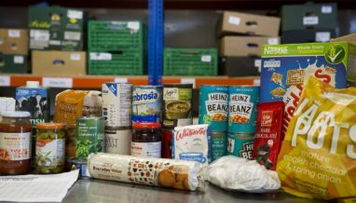

Please continue to bring in your donations by Monday 10th October

