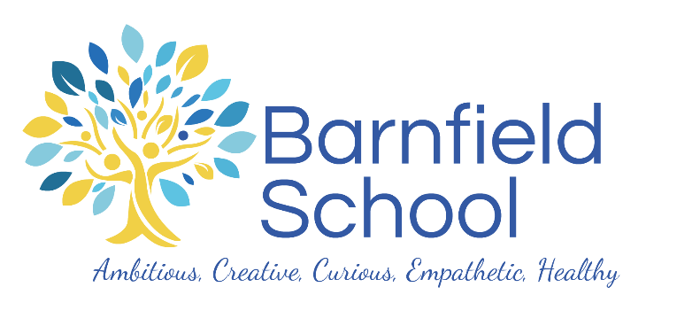

BARNFIELD PRIMARY SCHOOL

Post title: Early Years Educator / Nursery Nurse
Salary: Grade G, £33,957 - £37,443 Pro Rata

Early Years Educator / Nursery Nurse to start April 2024
36 hours per week, Monday to Friday
39 weeks per year, Term time + INSET days

Are you a passionate, caring and full of enthusiasm?
Are you a champion of young people, committed to ensuring children fulfil their potential, giving them the self-belief to aim high from an early age?
Do you strive to ensure you and others are the best they can possibly be?

If yes, we have an exciting opportunity for you to play a significant role in the continued development of our wonderful school.

We are looking for a dynamic Early Years Educator / Nursery Nurse to join our fabulous team and ensure our pupils receive the best possible education, experiences and achieve great things in line with our values of producing creative, curious, ambitious, healthy and emphatic learners from an early age.

Barnfield Primary is a successful 2 form entry, multi-cultural school, situated in the diverse area of Burnt Oak, North West London. On almost every index of deprivation, Burnt Oak ranks the highest in the Borough of Barnet. We are therefore fully committed to making a difference to the lives and life chances of the young people and the community we serve. We strive to make a difference for all of our pupils and require like-minded leaders to join us in this quest.

The success of Barnfield is underpinned by the emphasis we place on high expectations and aspirations. We genuinely believe that all our children have infinite potential and it is our role to champion, motivate and inspire them so they can succeed. Our EYFS setting truly embraces and reflects our vision and values.

A statement of application, no longer than 2 sides of A4, must be emailed to quigley@barnfield.barnetmail.net. CVs will not be accepted. Those candidates whose applications we are pursuing will be contacted and invited to interview.

We reserve the right to close this vacancy early should we receive an overwhelming response.
We therefore encourage applicants to submit their applications as soon as possible. All candidates are advised to refer to the job description and person specification before making an application.

Closing Date: 12pm, Monday 22nd April 2024
Interviews will be arranged individually

Barnfield Primary School is committed to safeguarding and promoting the welfare of children and young people, and we expect all staff and volunteers to share this commitment. We value and celebrate the cultural diversity of our school community, and we seek to promote equality of opportunity for all applicants. We want our people to reflect the diversity of our communities, and we welcome applications from people from all backgrounds, especially from under-represented groups, including those from Black, Asian and minority ethnic communities.

Please note that all appointments are offered subject to an enhanced barred list check through the Disclosure and Barring Service. Disclosures include details of cautions, reprimands or final warnings, as well as convictions, spent or unspent. The position is also subject to two good safeguarding references (one of which must be from a current or most recent employer), medical clearance and a 6-month probationary period. References will be taken up prior to interview. In line with our safeguarding practices, we are unable to accept CV’s.

If you are currently living overseas or have lived / worked overseas in the last five years please be aware that you will be required to provide an overseas criminal records check from the country/countries you have resided in, if you are the preferred candidate for the post.

All qualifications will be verified to ensure the protection and safety of children and young people.

